SIMATS ENGINEERING
ASSESSMENT TOOL 2

COURSE NAME: MLA03

COURSE CODE: Reinforcement learning

COURSE OUTCOME COVERED

CO1: Analyze reinforcement learning frameworks and Markov Decision Process concepts to model decision-making problems.( BL2, BL3)

Assessment Tool Weightage: 50%

Dr G.A. SENTHIL

QUESTIONS: 10 Total Marks:50

Annexure A

Constraint - Based Problem-Solving

Code of Conduct:

I A Karthikeyan (Name / Reg No) certify that this submission is my original work and that I have adhered to the guidelines specified for this assessment.
I understand that any violation of academic integrity rules will result in disciplinary action.

Signature of the student: A Karthikeyan

Qn 1)
import numpy as np import random

grid_size = 5
goal = (4, 4)
obstacles = [(2, 2), (1, 3)]

actions = [(0,1),(0,-1),(1,0),(-1,0)]
Q = np.zeros((grid_size, grid_size, 4))

alpha = 0.1
gamma = 0.9
epsilon = 0.2
for episode in range(500): state = (0,0)
while state != goal:
if random.random() < epsilon: action = random.randint(0,3)
else:
action = np.argmax(Q[state[0], state[1]])

move = actions[action] next_state = (
max(0,min(grid_size-1,state[0]+move[0])), max(0,min(grid_size-1,state[1]+move[1]))
)

if next_state in obstacles: reward = -10 next_state = state
elif next_state == goal: reward = 100
else:
reward = -1

Q[state[0],state[1],action] += alpha * (
reward + gamma * np.max(Q[next_state[0],next_state[1]])
- Q[state[0],state[1],action]
)

state = next_state print(Q)

OUTPUT

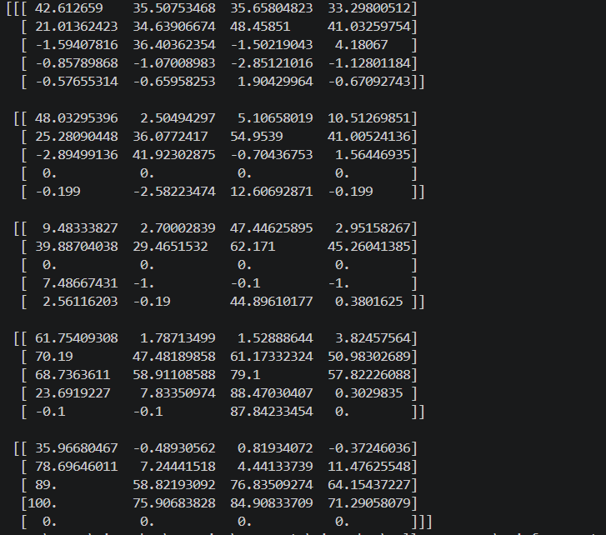

Qn 2)
import numpy as np import random

arms = [0.2, 0.5, 0.8]
epsilons = [0.1, 0.3, 0.5]

for epsilon in epsilons:
Q = np.zeros(3)
N = np.zeros(3) reward_sum = 0
for i in range(500):
if random.random() < epsilon: arm = random.randint(0,2)
else:
arm = np.argmax(Q)
reward = 1 if random.random() < arms[arm] else 0 N[arm] += 1
Q[arm] += (reward - Q[arm]) / N[arm] reward_sum += reward

print("Epsilon:", epsilon) print("Rewards:", reward_sum)

OUTPUT:
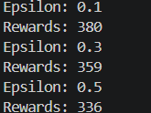

Qn 3)
states = ["Start", "Road", "Destination"] actions = ["Move", "Wait"]

transition = { "Start":{"Move":"Road"},
"Road":{"Move":"Destination"}, "Destination":{"Move":"Destination"}
}

reward = { "Start":-2,
"Road":-1, "Destination":100
}
energy = 20 state = "Start"
while state != "Destination" and energy > 0: action = "Move"
state = transition[state][action] energy -= 5
print(state, reward[state], energy)

OUTPUT:


Qn 4)
import numpy as np grid = 4
gamma = 0.9

V = np.zeros((grid,grid)) goal = (3,3)
for iteration in range(100): newV = V.copy()

for i in range(grid): for j in range(grid):

if (i,j)==goal: continue

values=[]
for dx,dy in [(1,0),(-1,0),(0,1),(0,-1)]:

ni=max(0,min(grid-1,i+dx)) nj=max(0,min(grid-1,j+dy))

reward=-1 values.append(reward+gamma*V[ni,nj])
newV[i,j]=max(values)

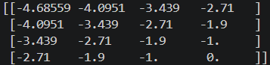
V=newV print(V) OUTPUT:

Qn 5)

battery = 30
deliveries = 0

while battery >= 5: deliveries += 1
battery -= 5 print("Delivery", deliveries)

print("Maximum Deliveries =", deliveries)

OUTPUT:
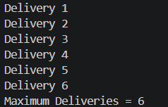

Qn 6)
signals = ["North", "East", "South", "West"] emergency = "East"
for signal in signals:
if signal == emergency: print(signal, "GREEN")
else:
print(signal, "RED")

OUTPUT:
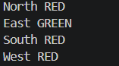

Qn 7)

import random bandwidth = 100
for packet in range(10):
usage = random.randint(5,20) if bandwidth >= usage:
bandwidth -= usage reward = 10
print("Packet Sent", reward) else:
reward = -5 print("Dropped", reward)
print("Remaining Bandwidth:", bandwidth)

OUTPUT:
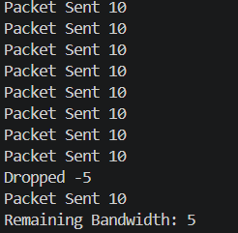

Qn 8)

import random arms = [0.3,0.6,0.8]
random_reward = 0

for i in range(500):
arm = random.randint(0,2)
random_reward += 1 if random.random()<arms[arm] else 0 print("Random Reward:", random_reward)
epsilon = 0.1

Q=[0,0,0]
N=[0,0,0]
reward_sum=0

for i in range(500):

if random.random()<epsilon: arm=random.randint(0,2)
else:
arm=Q.index(max(Q))
reward=1 if random.random()<arms[arm] else 0 N[arm]+=1
Q[arm]+= (reward-Q[arm])/N[arm] reward_sum+=reward
print("Epsilon Greedy Reward:", reward_sum)

OUTPUT:
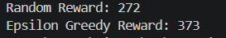

Qn 9)

battery = 100

no_fly = [3,5]
for location in range(1,8): if location in no_fly:
print("Avoid Location", location)
continue

if battery < 15: print("Battery Low") break

battery -= 15

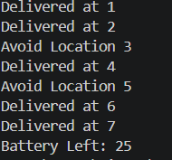
print("Delivered at", location) print("Battery Left:", battery) OUTPUT:

Qn 10)

import random threshold = 80
usage = 0

for hour in range(24):

consume = random.randint(2,6)

if usage + consume <= threshold: usage += consume
reward = 10 else:
reward = -10

print("Hour:", hour+1, "Usage:", usage, "Reward:", reward) print("Total Energy Used:", usage)

OUTPUT:
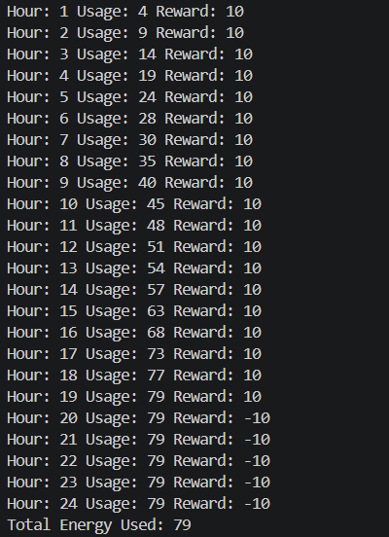

\RUBRICS FOR CALCULATION

Criteria | Weightage | Level 4 (Exemplary) | Level 3 (Proficient) | Level 2 (Developing) | Level 1 (Beginning)
Problem Understanding | 25% | Clearly defines the problem and identifies all relevant constraints  accurately | Identifies most constraints with minor gaps | Partial understanding; misses key constraints | Fails to identify constraints correctly
Constraint Analysis | 25% | Analyzes constraints effectively and prioritizes them  logically | Provides reasonable analysis with some  prioritization | Limited analysis; weak prioritization | No meaningful analysis or prioritization
Solution Development | 25% | Develops optimal and feasible solutions satisfying all constraints | Develops workable solutions with minor limitations | Solutions partially satisfy constraints | Solutions do not meet constraints
Application of Concepts | 15% | Effectively applies appropriate concepts,  methods, or tools | Applies concepts with minor errors | Limited application; requires guidance | Unable to apply relevant concepts
Justification | 10% | Provides strong justification for  decisions with logical reasoning | Provides justification with some clarity | Weak or unclear justification | No justification provided

